GET433 VSAM Activities

In your GET 433 CARDLIB CREATE A CARD LIKE THIS (OPTION 3.3 SHOULD WORK):

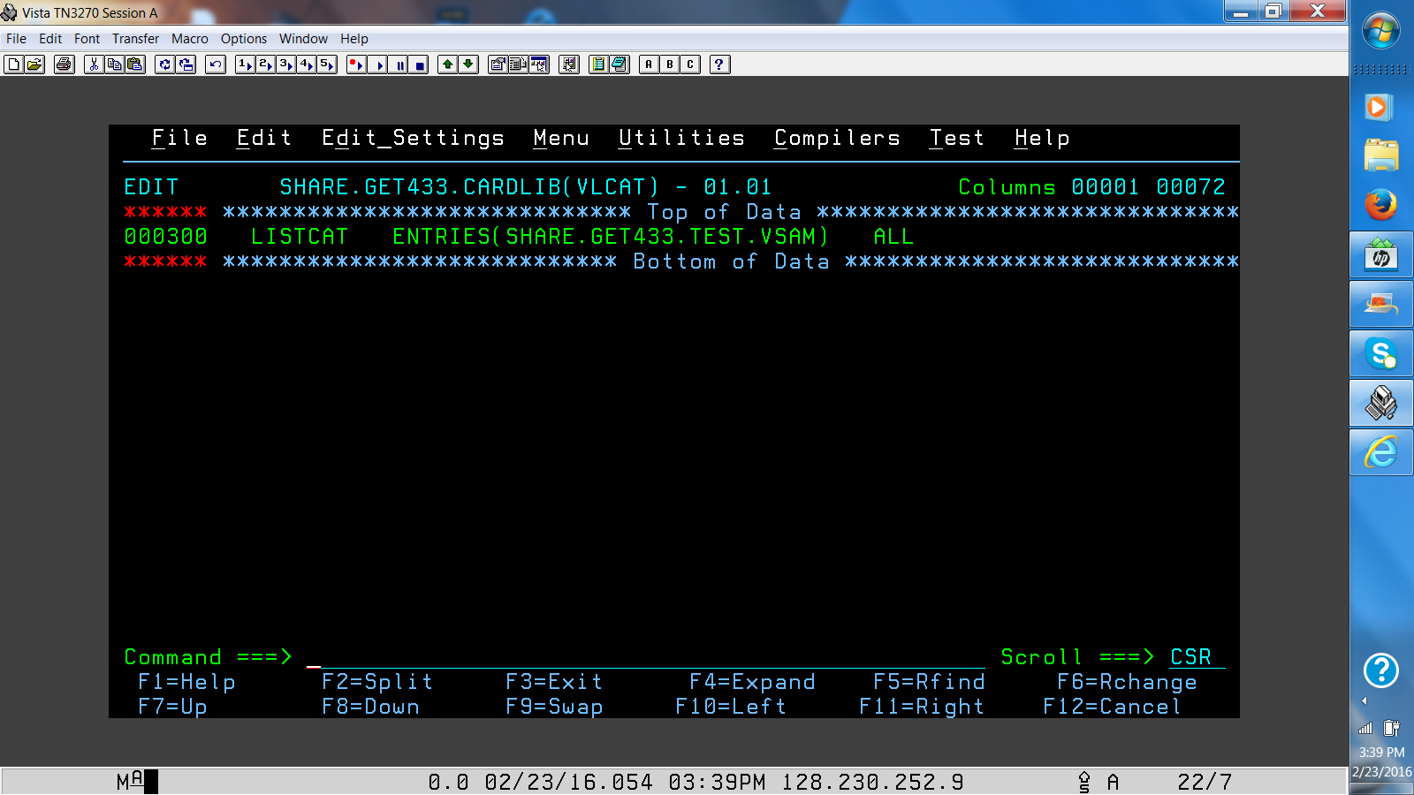

In your GET 433 CARDLIB CREATE A CARD LIKE THIS (OPTION 3.3 SHOULD WORK):

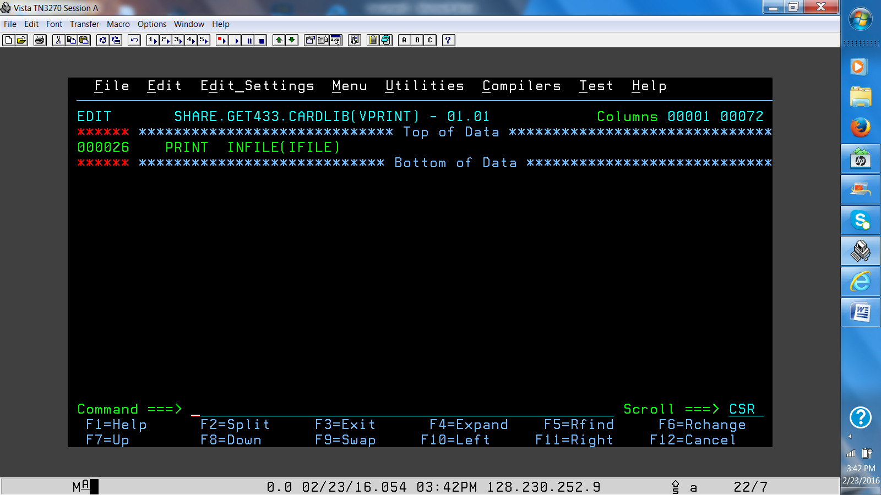

In your JCL Library - create a member like this - change SUF0003 to your RACF-id.

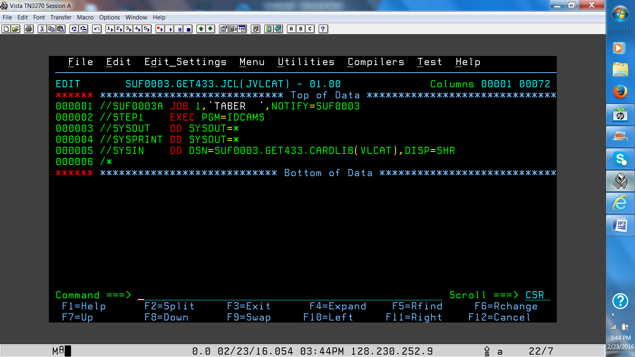

Run the JCL and check the output (=SD;ST) look for SYSOUT.

Create a member like:

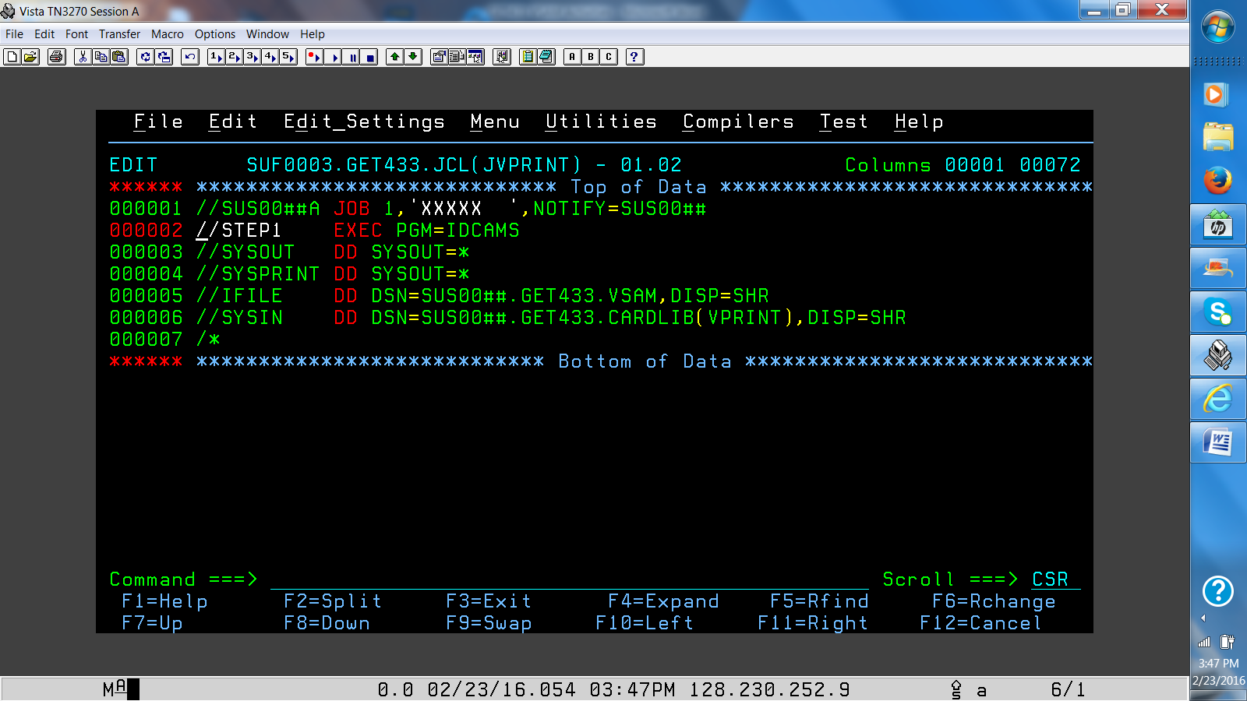

Make sure to change ## to your RACF-id numbers -

Run the job and check the output.

Screen print the outputs - submit in Blackboard.